Game Design Document

Fill up the following document

1. Write the title of your project.

Football

1. What is the goal of the game?

The goal of the game is to goal the ball

1. Write a brief story of your game.

The scene is of a football match. It is a two person game. There are

two players in the game and a football. We have to goal the ball at

The opposite goal post to get the points.

1. Which are the playing characters of this game?

* Playing characters are the ones who respond to the user based on the input from the user.
* Cars, monkeys, dinos, wizards, etc., are the playing characters in the game.

|  |  |  |
| --- | --- | --- |
| Number | Character Name | What can this character do? |
| 1 | Player1 | They can move left and right and can kick the ball. |
| 2 | Player2 | They can move left and right and can kick the ball. |
| 3 |  |  |
| 4 |  |  |
| 5 |  |  |
| 6 |  |  |
| 7 |  |  |
| 8 |  |  |

1. Which are the Non-Playing Characters of this game?

* Non-Playing characters are the ones that don't have an action or behavior when the user interacts with the game.
* Hurdles, stones, bananas, coins, etc., are non-playing characters in the game.

|  |  |  |
| --- | --- | --- |
| Number | Character Name | What can this character do? |
| 1 | Football | If we press the space key the ball will move and it will bounce off from the edges and player1 & player2 |
| 2 | Background | It has a fixed place |
| 3 | Goal post | It has a fixed place |
| 4 |  |  |
| 5 |  |  |
| 6 |  |  |
| 7 |  |  |
| 8 |  |  |

Draw your imagination of this game. What does this game look like?

* Draw the game either on your computer or on paper.
* Add images of the game scenes to show each of the playing and non-playing characters at least once.

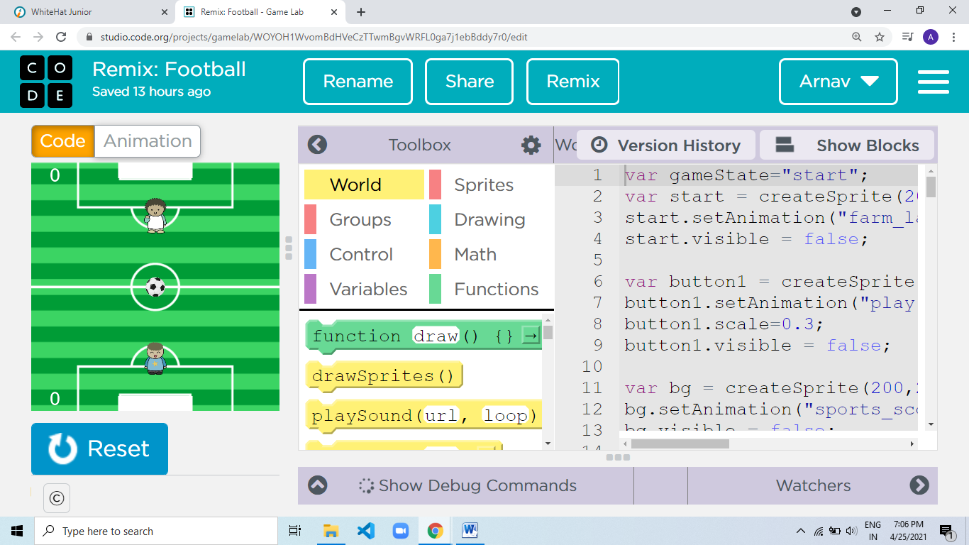

How do you plan to make your game engaging?

By making the levels harder (game adaptivity) as the point increases.